Application to Open or Change a Fund (FM003) Help

When to apply for a new fund
- When there is a new funding source
- When separate budget control and reporting is required
- New research funds must be opened via the Converis eResearch (eRA) system:
https://eraonline.uct.ac.za/converis/portal/overview?lang=en_GB

Completing form FM003

Section A
- Specify if you want to open a new fund or change an existing fund.
- For research funds, specify the new fund number on the form.
- For NRF and MRC funds, this can be obtained from Central Research Finance (see form NRF Fund Maintenance - Applying for new NRF funds).
- For other research funds, this can be obtained from your Faculty Finance Office.
- Fund application refers to:
GOB | General Operating Budget (UCT Council approved)
Non-GOB | Non-General Operating Budget
Research | Research-related
Inv No 1 | Investment in portfolio 1 (Endowment)
Inv No 2 | Investment in portfolio 2
Inv No 3 | Investment in portfolio 3 (Cash)

- Attach supporting documents (e.g. contract, grant letter), if the fund opening request is not being submitted via Converis.
- If a new cost object is required, please forward CO103 to fnd-finance@uct.ac.za.
- If relevant, attach CO113 (Fund / Cost Object Relationship) for multiple cost object links.

Section B
- Fund type refers to:
Council | Income and expenditure over which Council has absolute legal control and discretion of use, except for staff and student housing which is categorised separately.
Council – Student/Staff Housing | Council-controlled income and expenses relating to accommodation for staff and students; including catering costs.
Designated | Council has no discretion/control of this income and expenditure. This restriction may result from a contract (e.g. contract research), a condition of a grant (e.g. NRF grant), a bequest (i.e. a testamentary provision in a will), or a condition stipulated in a notarial deed of donation.
Related Party/Non-UCT | 3rd party receipts and distribution of funds, where UCT acts as an agent.

Refer to Attachment A for a graphic presentation of the above and Attachment B for bursary-specific guidance.

- Budget Structure Template (BST)
Is a template that restricts postings to certain Commitment Item Groups.
- Maintain Balance (MB)
Indicates if actual balance is carried forward to the next fiscal year for reporting purposes.
- Revenue Increasing Budget (RIB)
Indicates if revenue will increase budget available.
- Year End rule
Select yes if the budget remaining at year end closes off to a different fund (generally Council controlled and NRF research funds must have Year End rules). If the fund closes off to itself, select no.

Section C
- Where the new fund is an investment fund, approval by Treasury is required before Ledgers can open the fund.

Once the FM003 form is complete
Non-research funds:

- Send the FM003 and supporting documents to fnd-ledgers@uct.ac.za if not an investment fund, or fnd-treasuryreq@uct.ac.za if an investment fund.
- Ledgers will inform you when your fund has been opened and will provide you with the fund number.

Research funds:

- FM003 for research funds to be submitted via the Converis eResearch (eRA) system

Attachment A:

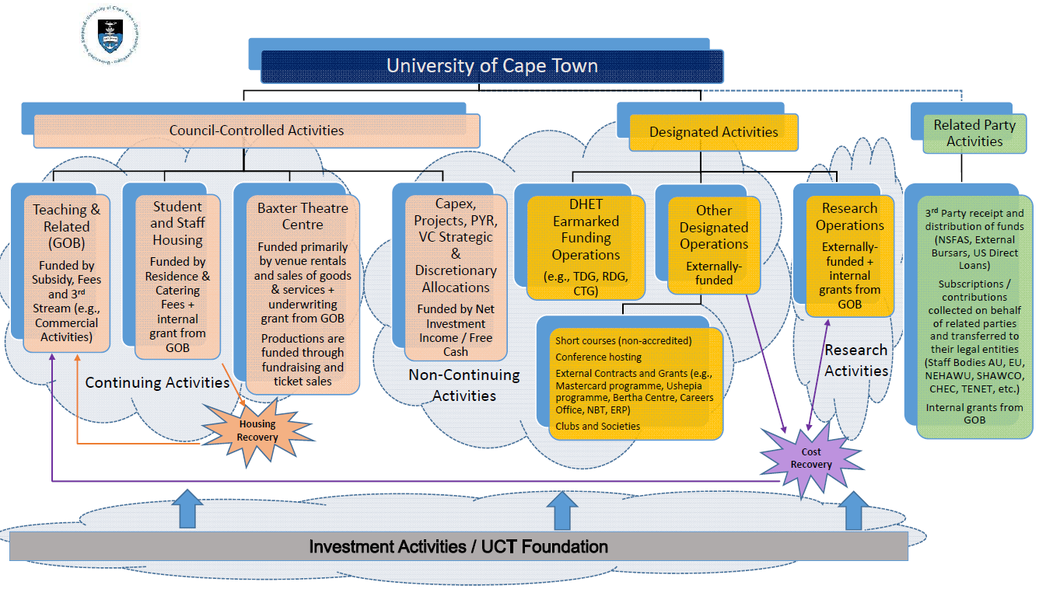

Attachment B:

Below are examples of what fund type is appropriate when opening bursary funds:

Fund type | Bursary scenario
Council-controlled | - Money received with no terms and conditions and UCT decides to use the money for bursaries.  - GOB allocation for bursaries.
Designated | - Money received with a stipulation that the money be used for bursaries, but UCT can decide on the students that will receive the bursaries. Example: Funder stipulates: "R10 000 donation to be used for bursaries for students in their 3rd year engineering degree".  - Bursaries where UCT provides the funder with a list of students and the funder chooses which students they want to give bursaries to.
Related party/non-UCT | - Money received where the funder specifies which students must receive the money (without any UCT involvement). Therefore, UCT is just acting as an agent to allocate the money on to the student's fee account). Example: Funder says: "R10 000 each for students x, y and z".  - All NSFAS funding

