COMPLETING THE SHORT COURSE APPROVAL FORM
ACA031

When do I complete this form?
This form is used by departments and faculties when they wish to
- Introduce a new short course that has never been offered
- Change the title, course code or any other aspect of an existing short course
A short course is defined in the UCT Continuing Education Policy as a course that is not credit-bearing, likely to be taken for personal enrichment and/or professional development, and involves less than 1 200 notional hours of study.

Completing this form

This form is divided into 2 sections:

- Section A covers information regarding the content of the course. This section must be completed by the departmental staff member proposing the course. Once this is completed, the form must be submitted to the Head of Department and to the Dean for approval.
- Once Section A is completed, and the HoD and Dean have signed this section, the form must be submitted to the Faculty-based office that is responsible for short course administration. This office must then complete all parts of Section B, except for 8.
- When Section B has been completed, the form and any attachments to the form must be uploaded to your faculties’ short course administration Vula site (see below).
You will notice that there are several kinds of supporting documentation that may be submitted with the form. The following kinds of documentation may be submitted:
- If the course is being offered in partnership with a third party, the contract or memorandum of understanding between the Faculty and that party will need to be uploaded with the form.
- A course budget will need to be uploaded to supplement the budgetary information provided in the form.
- Be sure to give supporting documentation clear ‘Display Names’ when you upload them to the Vula site (see below).

Where do I send this form?
This form should be uploaded to your faculties’ short course administration Vula site. Only Faculty-based officers and administrators who administer short courses will have access to this site. If you are in such a role, and do not have access to the Vula site, please contact Rumbi Görgens at rumbi.gorgens@uct.ac.za. Please see the table below for the names of the faculty Vula sites:

Faculty | Vula Site name
Centre for Open Learning | COL Short Course Admin
Commerce | Com Short Course Admin
EBE | EBE Short Course Admin
Health Sciences | FHS Short Course Admin
Humanities | Humanities Short Courses
Law | Law Short Course Admin
Science | Sci Short Course Admin

Procedure
Uploading the completed ACA031 Short Course Approval Form and required attachments to Vula.

- To log in to Vula, go to https://vula.uct.ac.za/portal and click on UCT Login.

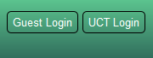

Log in using your staff number and UCT network password.
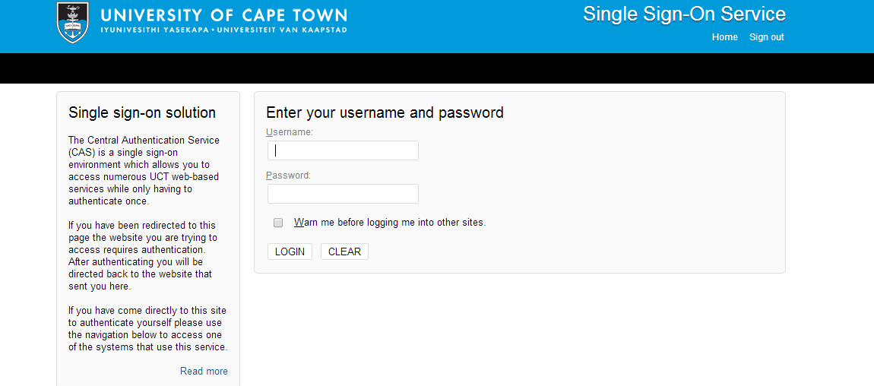

Once you have logged in, select your faculty’s Vula page:

If you cannot immediately find the site, click on More Sites.
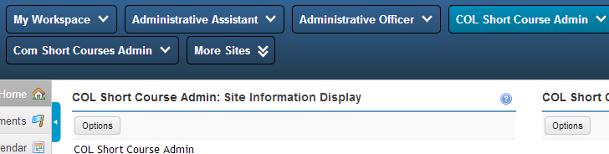

- Select Resources from the left hand navigation bar.
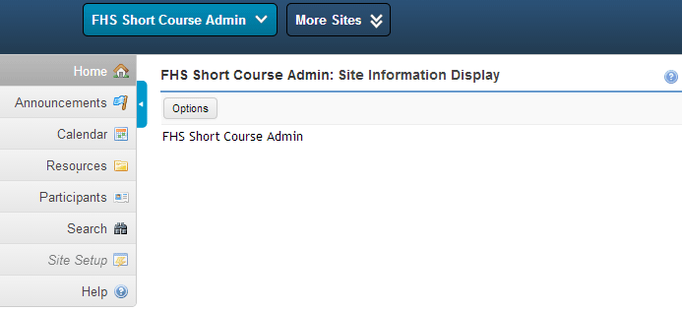

- You will upload the form to APPROVAL FORMS FOR SRO under Resources.
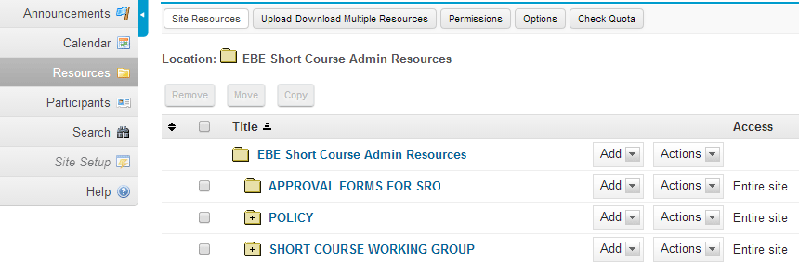

In APPROVAL FORMS FOR SRO click Add and select Upload Files.
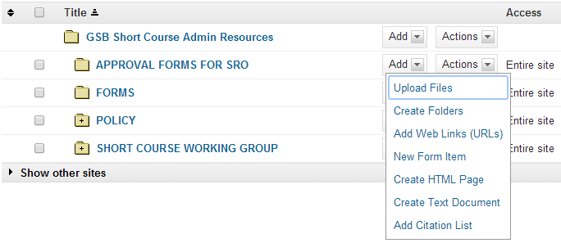
- The Vula: <Folder Name>: Resources page opens where you can upload the file directly from your computer.
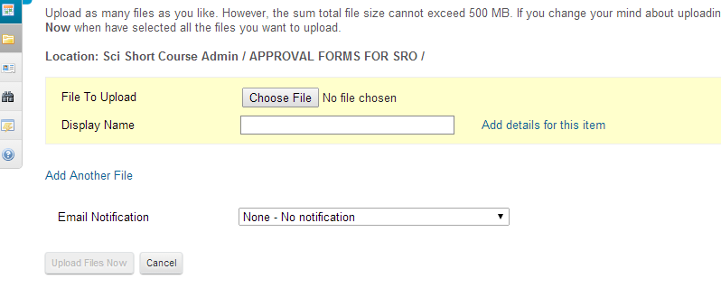
- Be sure to give your file a display name that clearly gives the course code and date. For example, ‘ACC1005CE 02042014’. Enter this information into the ‘Display Name’ field. If you are uploading supporting documentation, give them clear display names that reference the course code. For example, ‘ACC1005CE Budget’.

- In the Email Notification drop-down list select High – All participants to ensure that the Student Records Office receives notification that you’ve submitted a form.
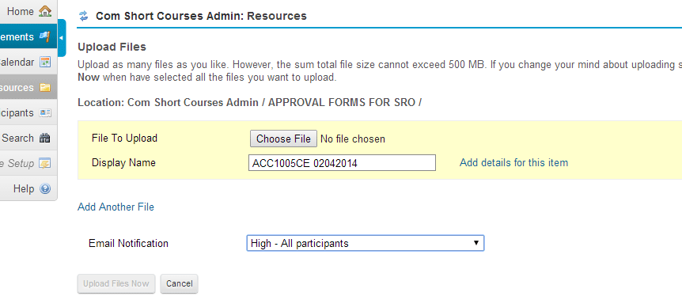

- Click Upload Files Now to upload the form and send an email notification to the Student Records Office.
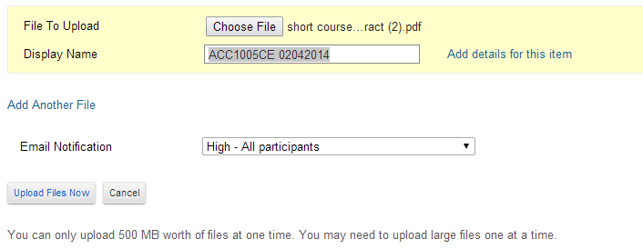

- Once the Student Records and Fees Offices have captured the form, it will be uploaded into your APPROVED COURSES folder and you will receive an email notification when this is done.

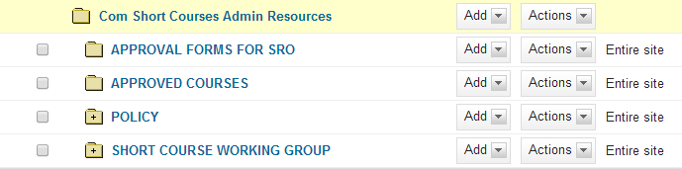

Where do I go for help?
If you require assistance with the completion and/or submission of the form, contact
Rumbi Görgens via rumbi.gorgens@uct.ac.za or on 021 650 4508.

