NRF fund maintenance – Applying for new NRF funds

Completing and submitting the FM003a form
- Complete Section A as per below of the FM003a form.
- Contact your Faculty Finance office for Fund center, Cost Object and Dept org code details
- Complete the Fund description and Fund name using the Excerpt of FM003a form: Fund description and fund name fields below.
- Type in the blocks below to ensure correct naming convention and number of characters.
- Ensure that all relevant signatures are obtained.

Excerpt of FM003a form: Fund description and fund name fields
Fund description (Max 40 characters)*
Complete fields as shown in the pop-out below, leaving spaces where shaded grey.
N |  | R |  | F
 |  |  |  |  |  |  | ORG |  |  |  |  |  | UID |  |  |  |  |  |  |  | SURNAME + INITIALS + PERIOD PROGRAMME

Fund name (Max 20 characters) *
Complete fields as shown in the pop-out below, leaving spaces where shaded grey.
N | R | F
 |  |  |  |  |  |  |  | UID |  |  |  |  |  |  | SURNAME
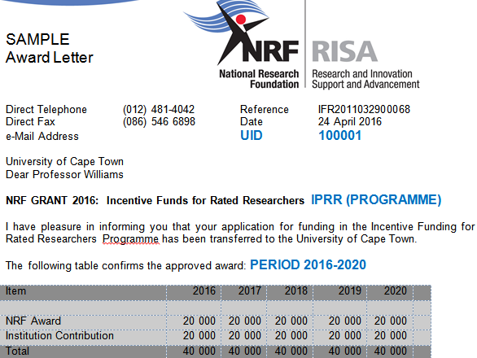

Example
Fund description (Max 40 characters)* | NRF FND 100001 WILLIAMS 2016-20 IPRR
Complete fields as shown in the pop-out below, leaving spaces where shaded grey.
N |  | R |  | F |  |  |  | F | N | D |  |  |  | 1 | 0 | 0 | 0 | 0 |  | 1 |  |  | W | I | L | L | I | A | M | S |  | 2 | 0 | 1 | 6 | - | 2 | 0 |  |  |  |  |  | I | P | R | R
 |  |  |  |  |  |  | ORG |  |  |  |  |  | UID |  |  |  |  |  |  |  | SURNAME + INITIALS + PERIOD PROGRAMME

Fund name (Max 20 characters) * | N | R | F |  | 1 | 0 | 0 | 0 | 1 |  | W | I | L | L | I | A | M | S
Complete fields as shown in the pop-out below, leaving spaces where shaded grey.
N | R | F |  |  |  | 1 |  | 0 | 0 | 0 | 0 | 1 |  |  |  | W | I | L | L | I | A | M | S
 |  |  |  |  |  |  |  | UID |  |  |  |  |  |  | SURNAME
- Attach a copy of each:
- NRF award letter and Acceptance of Grant Conditions (ACG) endorsed by the Research Office
- Forward the completed FM003 form to the relevant Senior Finance Officer in Central Research Finance for sign-off and processing. See below List of Contacts
- Always use the latest version of FM003a from the forms website: https://forms.uct.ac.za/forms.htm.
- One NRF project, i.e. one Grant UID number, should be used per fund. A new UID means a new Fund is to be opened.
- In the case of Thuthuka funds, where a new award letter and/or ACG is issued in the following year if the NRF agrees to fund it for another year and the UID remains the same, the existing Thuthuka fund is used again.

List of contacts in Central Research Finance
Please liaise with the relevant Senior Finance Officer in Central Research Finance (see contact details in table below) if you are unsure about any of the processes:

Contacts for faculties and departments (excluding Health Sciences)
Contact name | Ext. | Faculty | Departments
Merle Christians | 2005 | CHED | All
Merle Christians | 2005 | Humanities | All, including Libraries
Merle Christians | 2005 | Science | AGE, CEM, GEO, MCB
Linzi Kloppers | 2003 | Engineering | All departments
Linzi Kloppers | 2003 | Science | ACD, CSC, EGS, EEU, FSC, MAM, PHY
Rosina Mbobo | 2004 | Science | AST, BIO (merged: ADU, BOT, PFP, ZOO), CMS, SEA, STA
Nompendulo Gosa | 2007 | Law Faculty | All
Rosina Mbobo (Interim) | 2006 | Commerce | All
Rosina Mbobo (Interim) | 2006 | GSB | All

Contacts for Heath Sciences Faculty (contacts, dept. org codes, linked units)
Contact name | Dept.Org | Dept Org Codes/ Units linked to the department
Nompendulo Gosa | AAE
Nompendulo Gosa | AHS | DSP, LOG, NUR, OCT, PTH
Nompendulo Gosa | CHM | CHM, CTS, CVR, EAR, EMS MFS, NRS, OPH, ORT, URO
Nompendulo Gosa | MED | ANU, FME, HSE, MGS, MPG, PRI
Nompendulo Gosa | MDN | CLR, CCN, DER, GIT, GRN, IHD, MDN, MEN, MSA, MSH, MRE, NEU, PHA
Nompendulo Gosa | OBS
Nompendulo Gosa | PED | PDS, PED
Nompendulo Gosa | PPH | CMH, IHU
Nompendulo Gosa | PRY
Nompendulo Gosa | RAY | MDP, NUM, RAD, RAY
Nompendulo Gosa | HUB | ANT, BER, BME, NUT, PGY
Linzi Kloppers (Interim) | EMU
Linzi Kloppers (Interim) | IBS | CSB, DCB, MBI
Linzi Kloppers (Interim) | PAT | BMR, CLI, CPY, FMD, HAE, HMG, MMI, PAT, RPU, VIR
Merle Christians (Interim) | IDM

