**DDB05 – COA recommendation on examination**

**Note:** This form is used by the **Committee of Assessors (CoA)** when making a **recommendation** on the **examination** of a thesis submitted for the degree of **Doctor of Philosophy**.

|  |  |  |  |  |
| --- | --- | --- | --- | --- |
| **TO** | The Chair  Doctoral Degrees Board |  | **FROM** | The Chair  Committee of Assessors |

|  |  |
| --- | --- |
| **Section A: Student and thesis details** | |
| PhD Candidate Full Name |  |
| Student Number |  |
| Faculty |  |
| Department |  |
| Supervisor/s |  |
| Thesis Title |  |

|  |  |  |  |  |
| --- | --- | --- | --- | --- |
| **Section B: COA recommendation** | | | | |
| **Note:**   * Select **either** option **(i),** option **(ii)(a),** option **(ii)(b)**, option **(iii)** **or** option **(iv).** * If you selected **either** option **(ii)(a),** **(ii)(b)**, **or** **(iii)**, please **also** provide **any required details**. | | | | |
| **Option** | **Recommendation** | | | **✓** |
| **(i)** | The candidate should be awarded the degree and no further corrections to the thesis are required. | | |  |
| **(ii)(a)** | The candidate should be awarded the degree subject to the required corrections. The required corrections are **Trivial/Typographical.**  My suggestions are indicated in my report. These corrections do not alter the substance of the thesis in any fundamental manner and therefore major reworking or reinterpretation of the intellectual content of the thesis is not required. | | |  |
| **The supervisor(s)/ nominee\*** (enter name/s as applicable): has/have undertaken to see that these changes are satisfactorily made.  The DDB requires the candidate to submit a list of changes made (or why they have not been made). The degree will only be awarded after certification by the above named to the COA that the changes have been satisfactorily made.  **\****Select a nominee if the supervisor will not be undertaking these changes.* |  | | |
| **(ii)(b)** | The candidate should be awarded the degree subject to the required corrections. The required corrections are **Typographical and more substantial, specified changes.**  My suggestions are indicated in my report. These corrections do not alter the substance of the thesis in any fundamental manner and therefore major reworking or reinterpretation of the intellectual content of the thesis is not required. | | |  |
| **The supervisor(s)/ nominee\*** (enter name/s as applicable): has/have undertaken to see that these changes are satisfactorily made.  The DDB requires the candidate to submit a list of changes made (or why they have not been made). The degree will only be awarded after certification by the above named to the COA that the changes have been satisfactorily made.  **\****Select a nominee if the supervisor will not be undertaking these changes.* |  | | |
| **(iii)** | The candidate should be invited to address the **substantive** concerns of the examiner (s) and to revise and resubmit the thesis for re-examination by: | |  | |
| **Examiner(s)** (enter name/s as applicable)**:** |  | | |
| **(iv)** | The candidate should not be awarded the degree as the thesis has no prospect of meeting the requirements. | |  | |
| **Section C: COA’s reasons for arriving at this recommendation:** | | | | |
|  | | | | |

|  |  |  |  |  |  |
| --- | --- | --- | --- | --- | --- |
| **Section D: Approvals** | | | | | |
| **Action** | | **Print Name** | **Signature  (signature image)** | **Date** | **Option** |
| Approved By COA Chair |  |  |  |  |  |
| Approved By: | |  |  |  |  |
| DDB Chair |  |
| Deputy DDB Chair |  |
| Referred to DDB Meeting by: | |  |  |  |  |
| DDB Chair |  |
| Deputy DDB Chair |  |
| DDB Decision |  |  |  |  |  |

|  |
| --- |
| **Section E: DDB Chair’s/Deputy DDB Chair’s reason for arriving at this recommendation:** |
|  |

|  |
| --- |
| COMPLETING A COA RECOMMENDATION FORM DDB05 and DDB05A |

## When do I complete this form?

This form is completed by the **Chair of the Committee of Assessors** in the Faculties of Commerce, Engineering and the Built Environment, Health Sciences, Humanities, Law and Science when making a recommendation on the examination of a thesis submitted for the degree of Doctor of Philosophy.

## How do I complete this form?

1. Complete *Section A: Student and thesis details.*
2. Complete *Section B: COA recommendation*:
   * Select the recommendation by clicking the applicable  check box.
   * If applicable, enter the name of the supervisor(s)/nominee, who will oversee that the corrections have been made, in the       text box field.
   * If applicable, enter the name of the examiner (s), who will re-examine the revised thesis, in the       text box field.
3. Complete *Section C: COA’s reasons for arriving at this recommendation*:
   * Enter the reason (s) for the COA arriving at the selected recommendation in the       text box field.
4. Complete *Section D: Approvals*:
   * Enter the name and signature of the Chair of the Committee of Assessors (COA Chair).
   * Enter the date signed.
   * Confirm the recommendation:
   * Click to expand the *select the appropriate the OPTION* drop-down list.
   * Select the applicable recommendation.

**Example:**

If you selected the first *Option (i)* checkbox in *Section B* (as shown below), then you need to confirm this and select *(i)* from *Option* drop-down list in *Section D*.

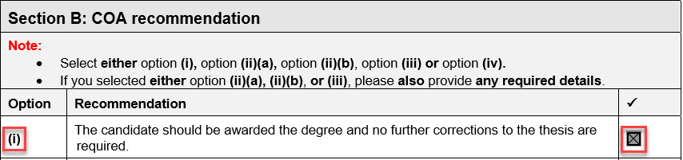

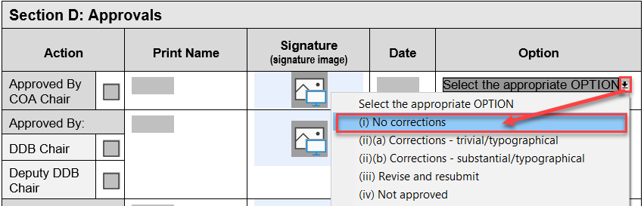

## Where do I send this form?

This form should be sent to the Doctoral Degrees Board Office ([ddb@uct.ac.za](mailto:ddb@uct.ac.za)) after the CoA Chair has approved the recommendation.

Thereafter, the Doctoral Degrees Board Office will send the form to the Chair of the Doctoral Degrees Board for final approval.